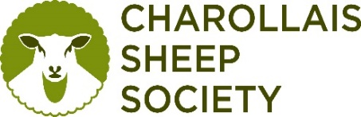
Customer Address: |  |  |  |  | Email address to send results to:
 |  |  |  |  | Wendy@charollaissheep.com
Return Address: | Charollais Sheep Society, Youngmans Rd, Wymondham NR18 0RR
Date of sample submission:
Sample ID number / barcode | Animal ID Number | Sire Ear Tag no. | Sex | Date of Birth | Sample Type | DNA | Scrapie
12345678910 | 21AB00123 | 18AB00012 | M/F | 15/03/2017 | Blood card | Y/N | Y/N
Genomics Samples, Neogen Europe Ltd, The Dairy School, Auchincruive, Ayr, KA6 5HU, Scotland, UK

